La Vallée du Rhône
Préciser pour chacune des étiquettes suivantes : la couleur produite sur l'appellation / les cépages / le département de production.
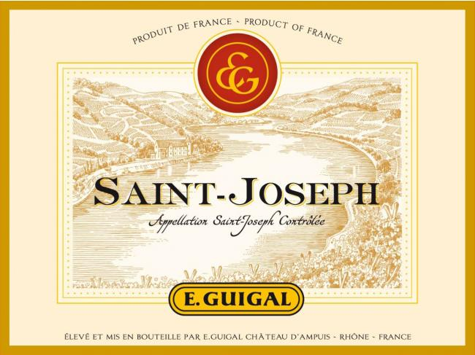

________________________________________________________________________________________________________________________________________________________________________________________________________________________________________________________________________________________________________________________________________
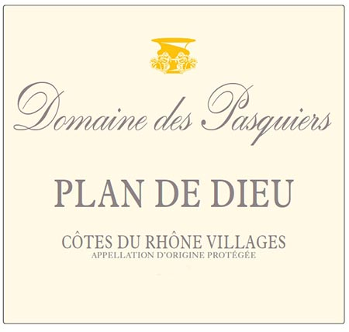

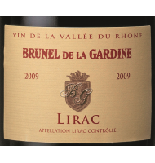
________________________________________________________________________________________________________________________________________________________________________________________________________________________________________________________________________________________________________________________________________

________________________________________________________________________________________________________________________________________________________________________________________________________________________________________________________________________________________________________________________________________
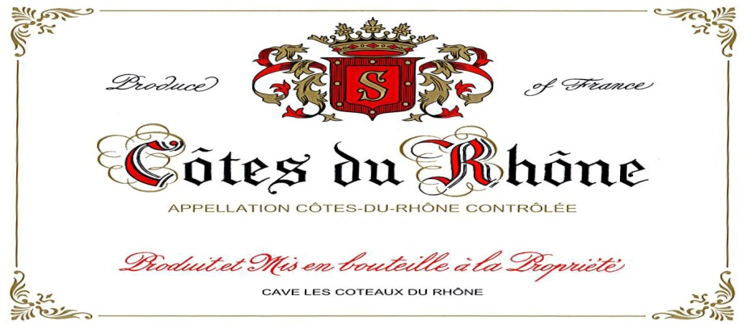

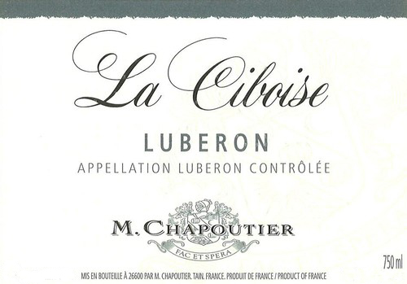
________________________________________________________________________________________________________________________________________________________________________________________________________________________________________________________________________________________________________________________________________

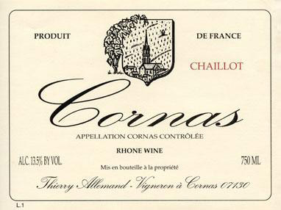
________________________________________________________________________________________________________________________________________________________________________________________________________________________________________________________________________________________________________________________________________

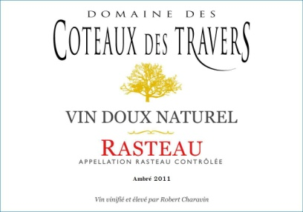
________________________________________________________________________________________________________________________________________________________________________________________________________________________________________________________________________________________________________________________________________

________________________________________________________________________________________________________________________________________________________________________________________________________________________________________________________________________________________________________________________________________

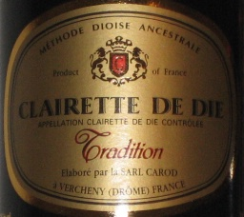
________________________________________________________________________________________________________________________________________________________________________________________________________________________________________________________________________________________________________________________________________

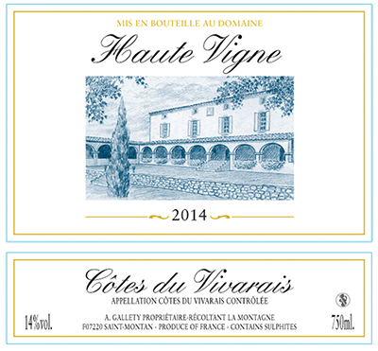
________________________________________________________________________________________________________________________________________________________________________________________________________________________________________________________________________________________________________________________________________

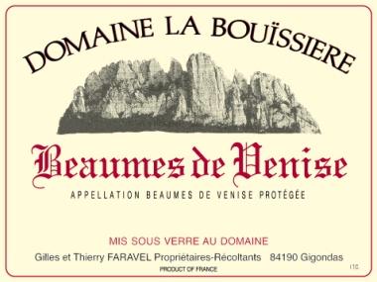
________________________________________________________________________________________________________________________________________________________________________________________________________________________________________________________________________________________________________________________________________

________________________________________________________________________________________________________________________________________________________________________________________________________________________________________________________________________________________________________________________________________
La Vallée du Rhône
Expliquer les vins produits sous l'étiquette suivante:
- Couleur
- Cépage autorisés
- Communes de production
- Département de production
- Rendement hec/har
- Superficie
Donner également le style des vins produits sous cette appellation.






