COMMUNIQUÉ DE PRESSE
C’est France qui accueillera le Concours ASI du Meilleur Sommelier du Monde 2022

...

VIDÉO DE PRÉSENTATION

https://www.youtube.com/watch?v=jQGL0-1Ic44&feature=youtu.be
Les urnes ont parlé et la France a gagné ! Par un vote secret des présidents des associations membres de l'Association de la Sommellerie internationale (ASI), la France a été choisie pour accueillir le prochain Concours du Meilleur Sommelier du Monde, qui aura lieu du 8 au 13 mai 2022.

"C'est un moment de fierté pour notre association ", a déclaré Philippe Faure-Brac, le président de la UDSF - Union de la Sommellerie Française. "Nous apprécions le vote de confiance de nos pairs en faveur à la fois de nos sommeliers et de la capacité de notre pays à accueillir un concours aussi prestigieux. Bien que notre programme se déroule à Paris, tous les sommeliers de France se joignent à moi pour s’engager à organiser et accueillir cet incroyable événement".
Quatre sites avaient brigué cet honneur. Leurs ultimes présentations ont mis en avant des atouts bien différents.
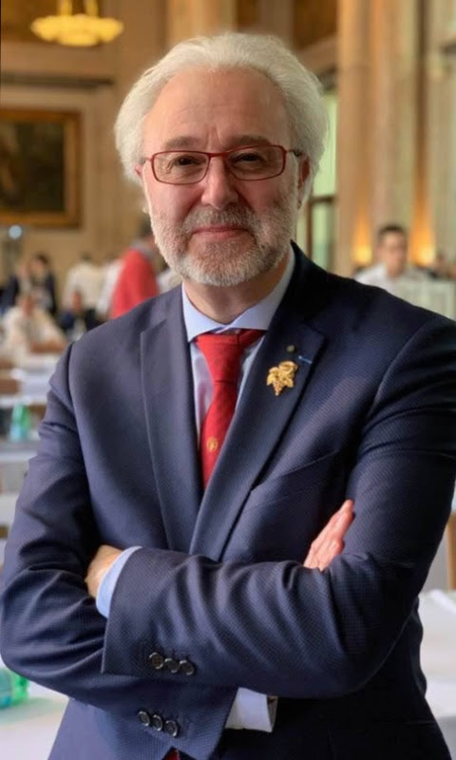

La France, berceau non seulement de l'ASI, mais aussi de la profession elle-même, a souligné son désir de partager son riche patrimoine viticole et sa prospérité avec la famille ASI.
Un autre candidat européen, la Lettonie, a mis l’accent sur la richesse culturelle, la qualité de vie fantastique à Riga et l'enthousiasme qu'elle pouvait susciter pour ce concours auprès du public.
La Nouvelle-Zélande, membre observateur, a axé son discours sur la beauté naturelle de l'île, l'hospitalité chaleureuse et la proximité des régions viticoles à partir d'Auckland.
Quant à la Géorgie, c’est la présidente elle-même de la nation, Salomé Zourabichvili, qui a lancé un appel passionné en sa faveur. Le pays a accueilli avec succès l'Assemblée générale de l'ASI en 2018 et proposait là Batumi, station balnéaire de la mer Noire, le genre d'endroit exotique susceptible de séduire les sponsors.

"Quels candidats fantastiques ! Notre seul regret est d'avoir été contraints d'en choisir un seul parmi eux ", a déclaré le président de l'ASI, Andrés Rosberg. "Maintenant que le vote s’est exprimé, nous avons hâte de travailler avec Philippe Faure-Brac et son comité hôte sur ce qui sera certainement un concours passionnant."
Le concours du Meilleur Sommelier du Monde de l'ASI est organisé depuis 1969. Le plus récent s'est déroulé à Anvers, en Belgique, en 2019, où Marc Almert, d'Allemagne, s'est imposé de
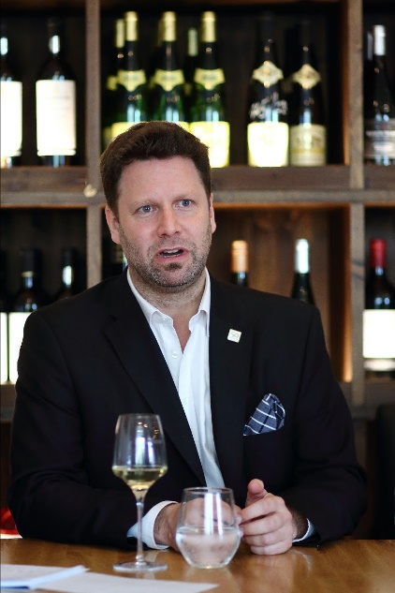

justesse face à un solide groupe de candidats hautement qualifiés. Le jury exceptionnel était composé d'anciens lauréats de concours internationaux de sommellerie, de présidents des associations membres de l'ASI et de quelques invités de marque du monde du vin.
L'ASI a été créée à Reims, en France, en 1969. Elle a récemment célébré son 50e anniversaire en Champagne, attirant des participants de ses 56 associations membres actifs et 5 pays observateurs.
Pour plus d'informations,
Liora Levi
Responsable Media & Communication
Michèle Chantôme
Secrétaire Général ASI
Directeur RP, Communication & Marketing
Philippe Faure-Brac
Président Union de la Sommellerie Française

